Documentation

**Aakash**

Group members:  
Aakash, Vani, Ashwin

I did these 6 points worth of items:

Design/Visual:

1 - Layout the level (Only one person in group can claim)

Coding:

1 - Particles used when ball is clicked

1 - Trigger event when player moves into area

1 - Add physics to slope assets that the ball can roll on.

1 - physics aggregates attached to new objects (Not what is already done for you, not using my addPhysics function)

1 - Detect if physics mesh touching other meshes to trigger events or messages (eg. Making a "You Win" object become visible). Use if (mesh.intersects(othermesh)) { do something }

**Vani Sree Mekala -StudentB**

Group members:  
Aakash, Vani, Ashwins

Design& Code Implementation for:

* (2 pts) Create panoramic 360° equirectangular sky image for skydome.

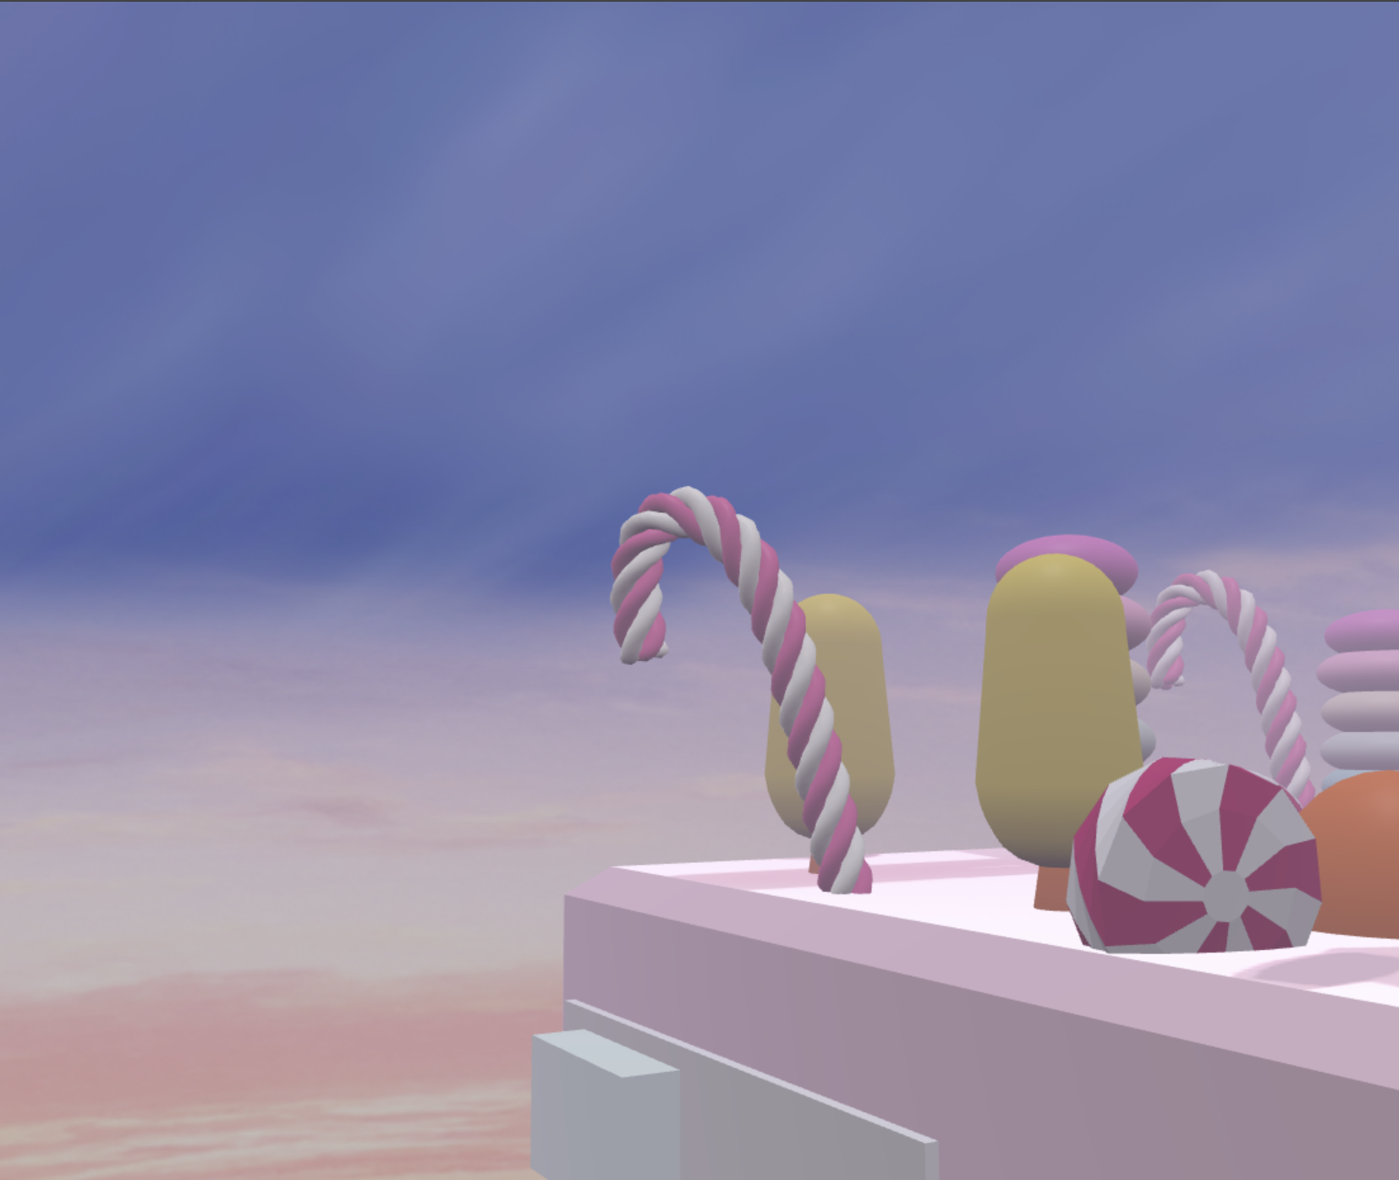

* (1 pt) Add emissive glow (neon lights, glowing objects)
* (1 pt) Add fog with color-matching theme

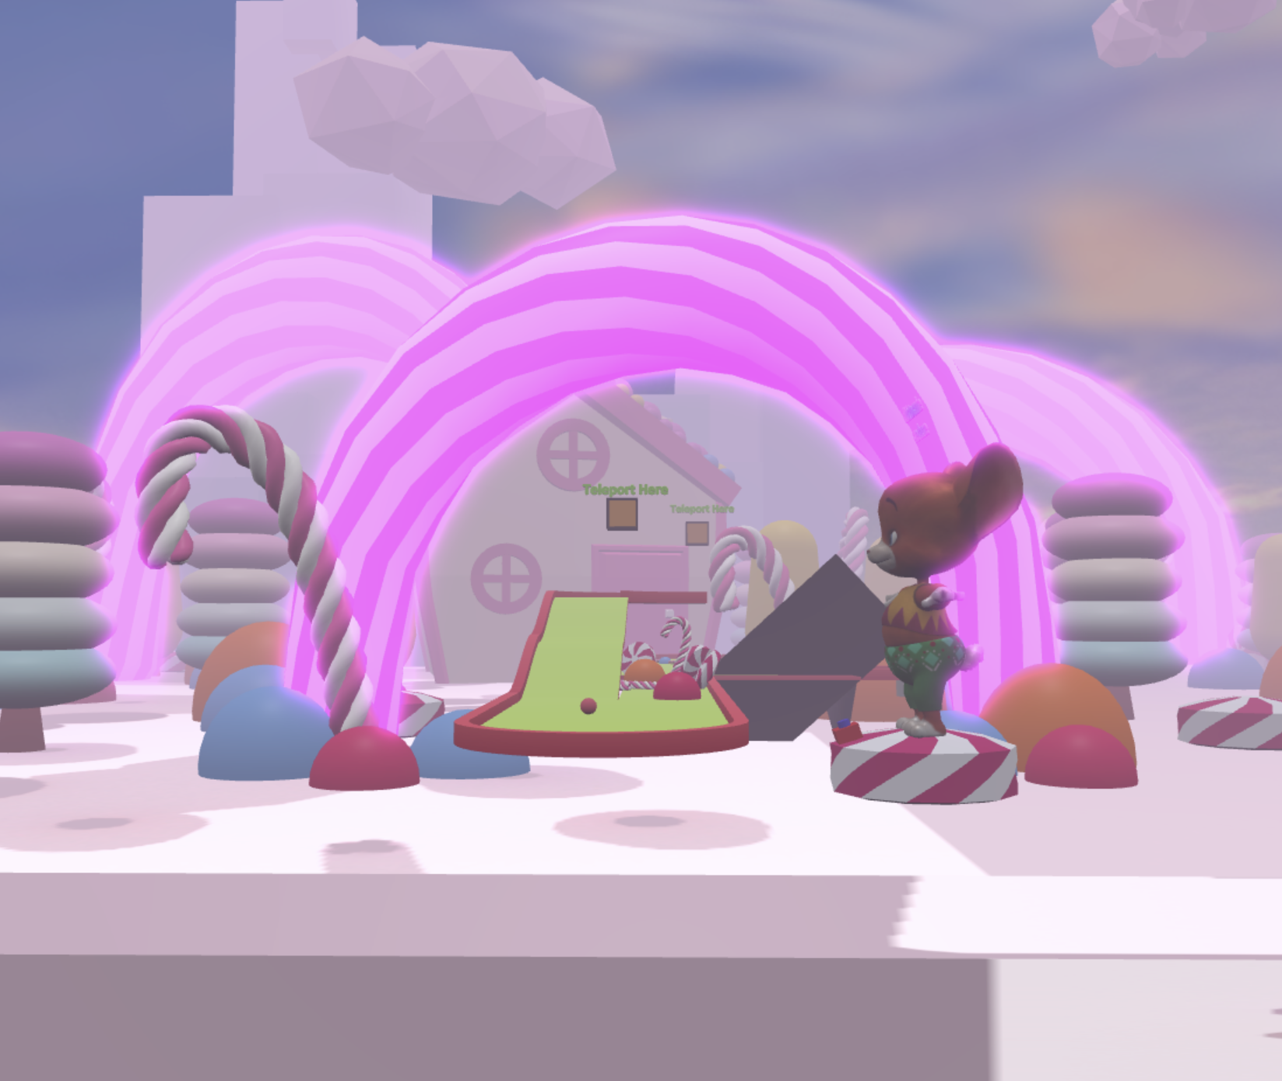

* (1 pt) Create your own material with Materialize (include .mtz file)  
  Saved everything in common.glb for materials as well. The source of the created materials is inside the images folder.

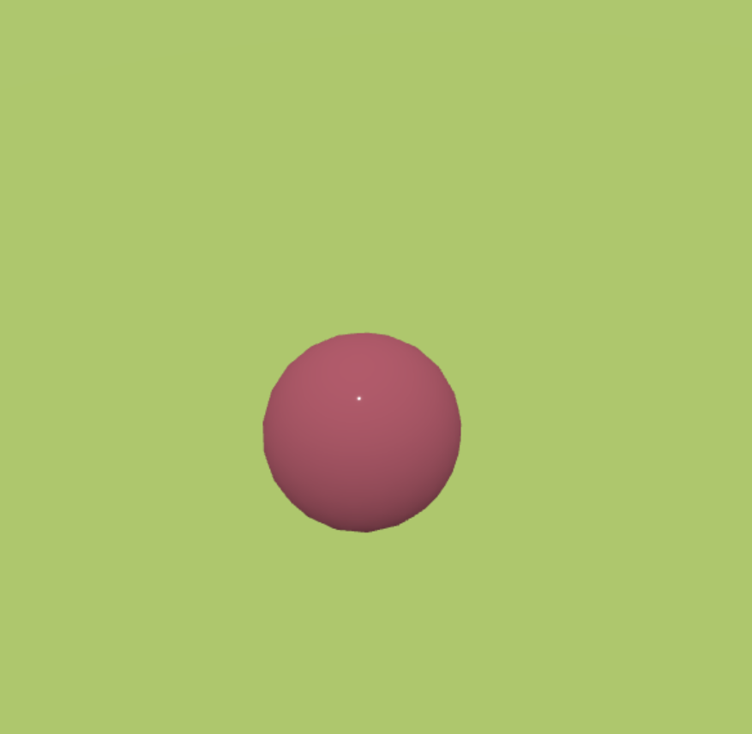

* (1 pt) Bake lightmap and apply shadow maps via code

--------------------------------------------------------------------------------------------------------------------------------------------------------------------------------------------------------------------------------------------------------------------------------------------------

**ASHWIN GEORGE – STUDENT D**

Design Items (2 points)

(1 pt) Create outline/cartoon style for certain interactable (inverted hull)

(1 pt) Vertex paint or bake lighting into vertices for props

Code Items (4 points)

(1 pt) Trigger music to play automatically on scene start



*-Added background sound in the start of the game. Shown in the above video.*

(1 pt) Sound triggered on action (hit gong, door opening sound)

*-Added quack sound to the ball*

(1 pt) Use teleport points instead of free teleport

(1 pt) Trigger animation on click (e.g., moving obstacle, rotating bridge)

